ACTIVITY – 07

Name: T. Jithendra

Register Number: 192111521

Course Code: DSA0163

Course Name: Object Oriented

Programming with C++

Dynamic Memory Allocation of Arrays:

#include<iostream>

using namespace std;

int main(){

int n;

cout << "enter the number : \n";

cin >> n;

int \*p = new int[n];

cout << "enter the elements in an array: \n";

for (int i=0;i<n;i++){

cin >> \*(p + i);

}

cout << "the values are: \n";

for (int i=0;i<n;i++){

cout << \*(p + i);

}

delete []p;

return 0;

}

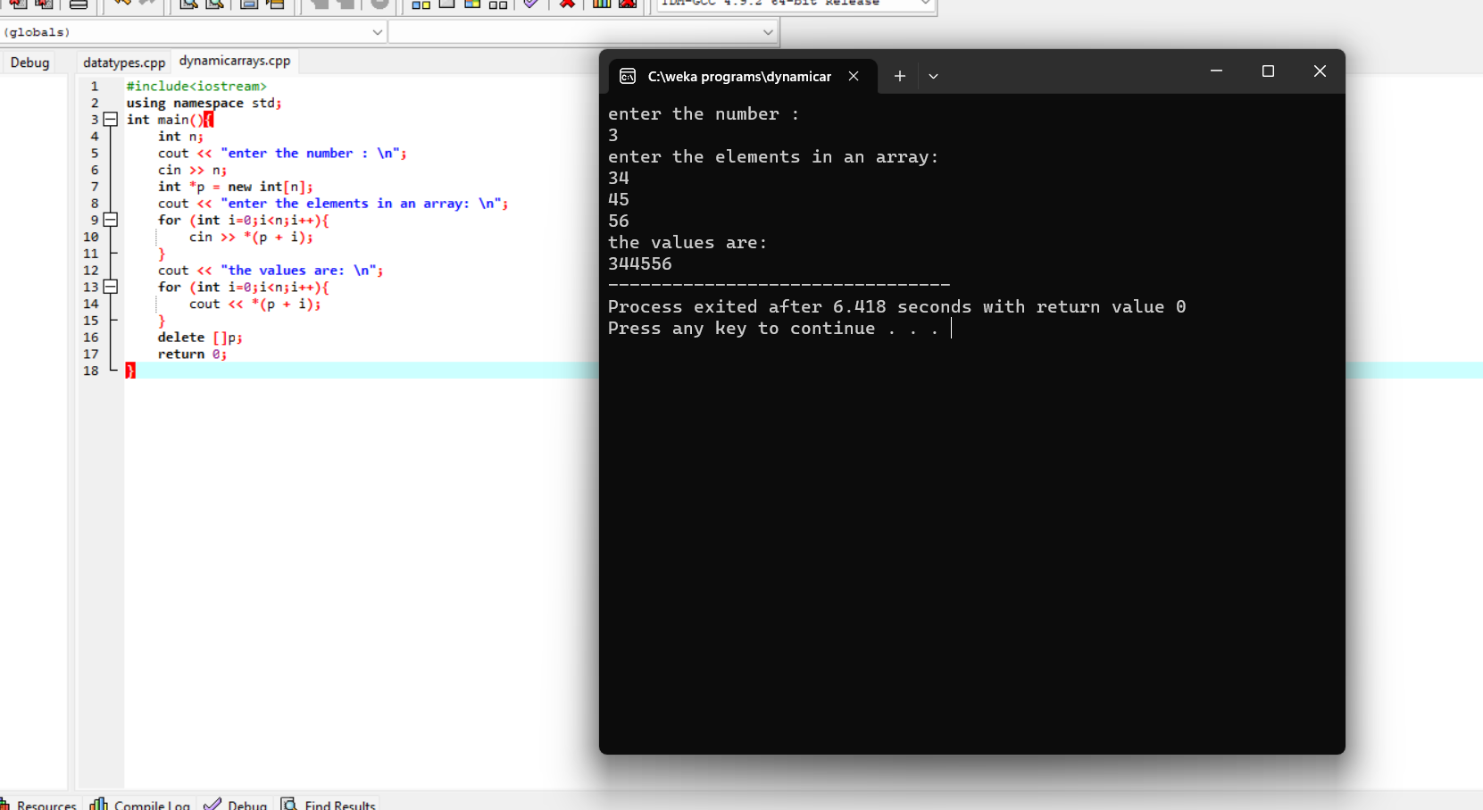

Dynamic Memory Allocation for Object:

#include<iostream>

using namespace std;

class A{

public:

int a;

A(){

a = 10 ;

}

~A(){

cout << " object destructed \n";

}

void print(){

cout << a;

}

};

int main(){

A \*A1 = new A;

A1->print();

delete A1;

return 0;

}

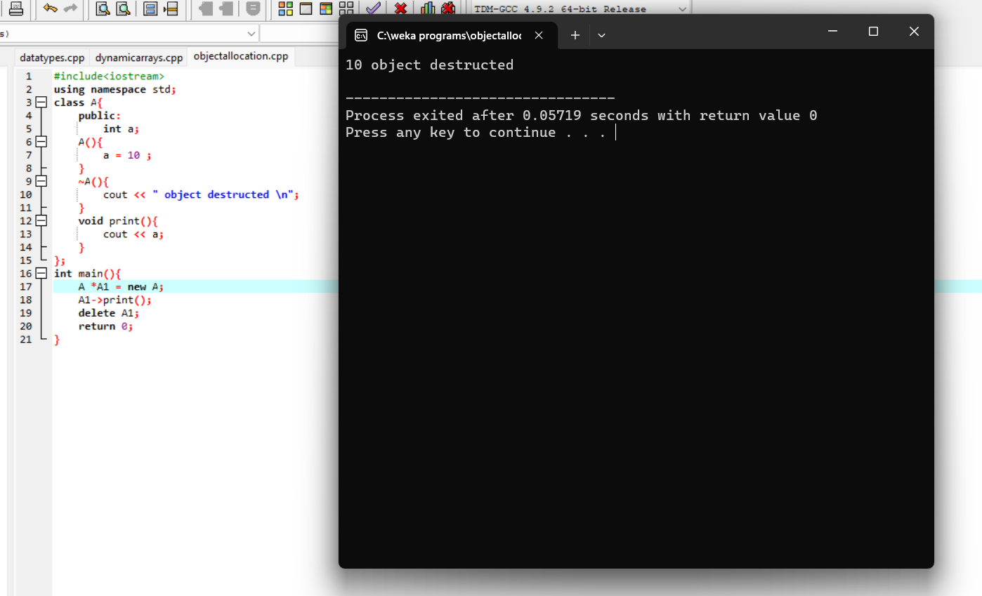

Array of Objects:

#include<iostream>

using namespace std;

class A{

public:

int a;

A(){

cout<<"Enter the values: ";

cin>>a;

}

~A(){

cout<<" object destructed. ";

}

void print(){

cout<<a;

}

};

int main(){

A A1[3];

A1[0].print();

A1[1].print();

A1[2].print();

return 0;

}

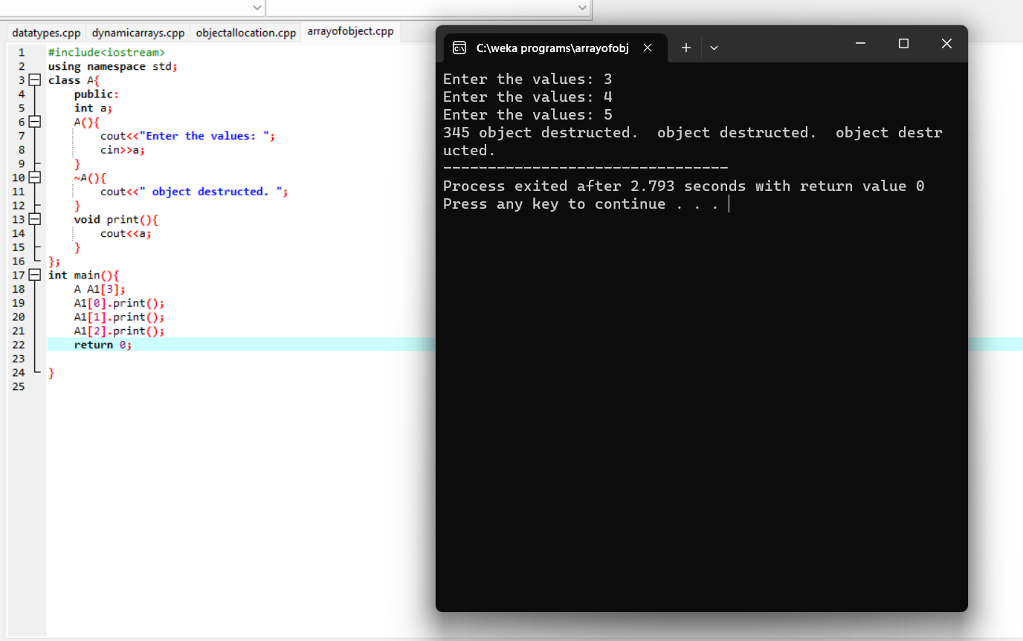

Dynamic Memory Allocation for Characters:

#include<iostream>

using namespace std;

int main(){

char \*p = new char;

\*p = 'g';

cout << \*p;

}

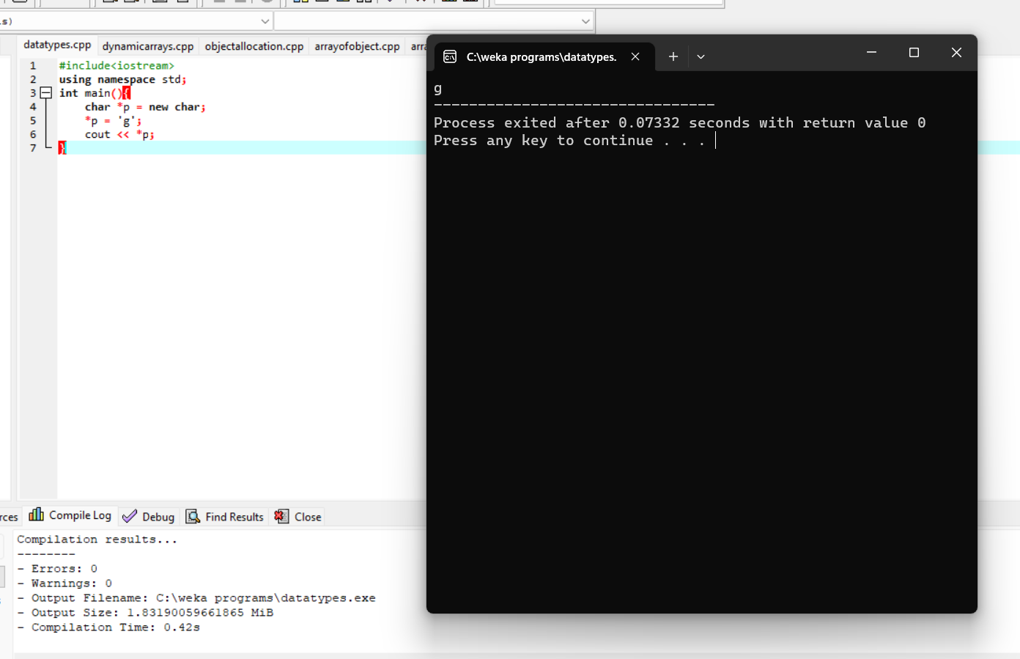

Dynamic Memory Allocation for Float:

#include<iostream>

using namespace std;

int main(){

float \*p = new float;

\*p = 3.14;

cout << \*p;

}

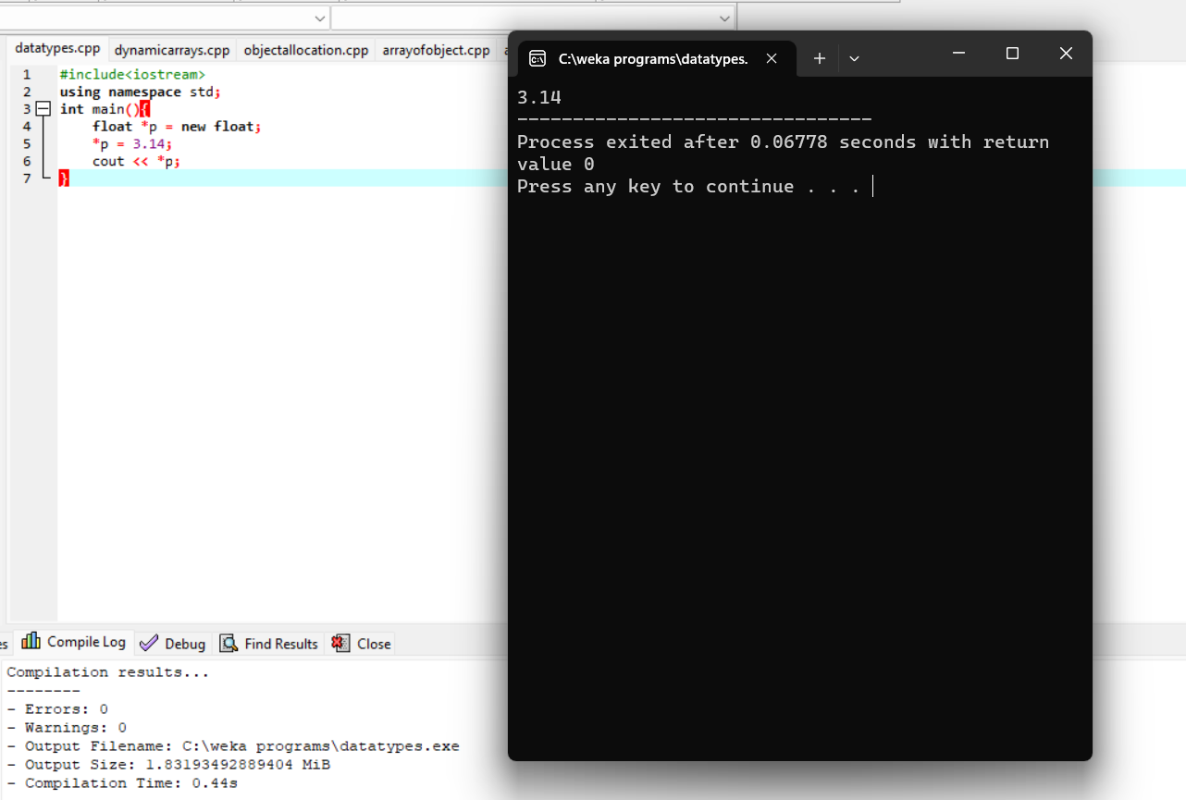

Dynamic Memory Allocation for String:

#include<iostream>

using namespace std;

int main(){

string \*p = new string;

\*p = "Jithu";

cout << \*p;

}

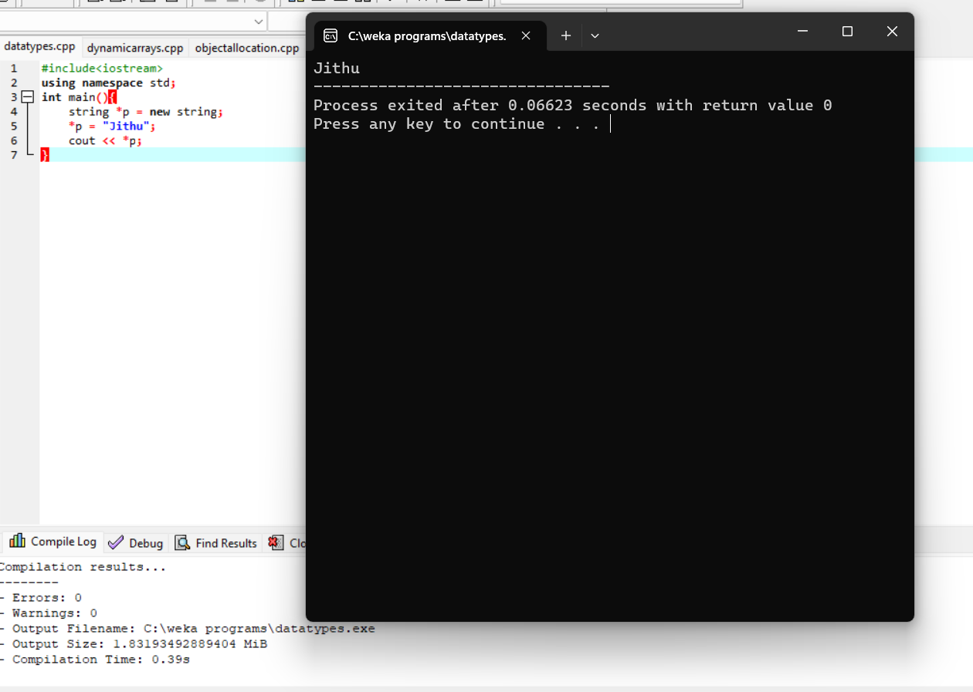

Dynamic Memory Allocation for Integers:

#include<iostream>

using namespace std;

int main(){

int \*p = new int;

\*p = 48;

cout << \*p;

}

